Denbora: 1h 05min

Dirua: 5€

Energia: 10

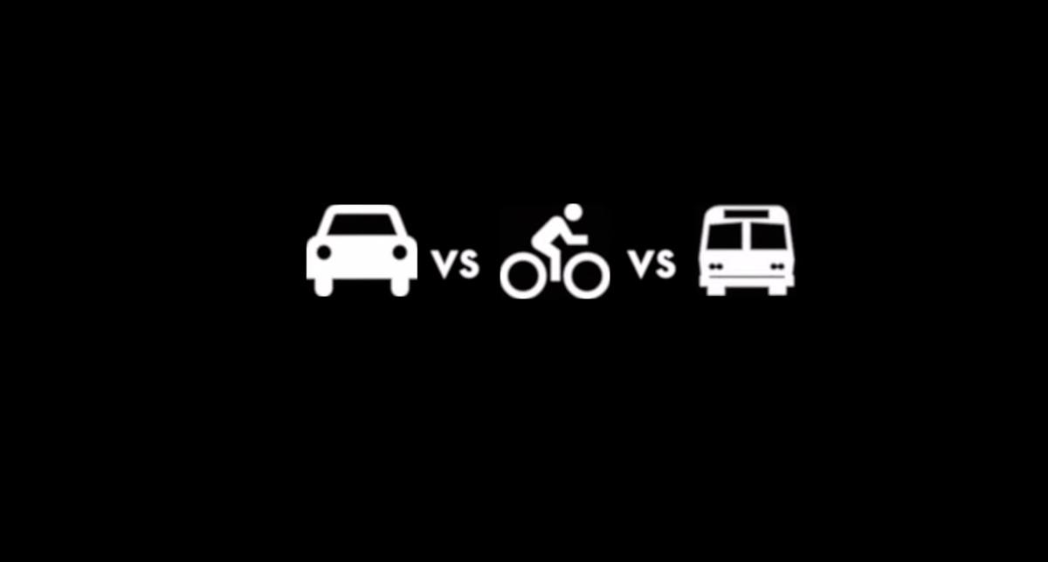

Erabaki nola joango zara

[Kotxez](http://docs.google.com/4.html) [Autobusez](http://docs.google.com/galdu7.html) [Bizikletaz](http://docs.google.com/7.html)